Employee Community Engagement:
A Statewide Partnership to Give Missouri Manufacturers a Competitive Advantage

United Way Agency Contact List

United Way Agencies in Missouri
Heart of Missouri United Way
United Way of Central Missouri
United Way of Greater Kansas City
United Way of Greater St. Joseph
United Way of Greater St. Louis
United Way of the Mark Twain Area
United Way of the Ozarks
United Way of Southeast Missouri
United Way of Southwest Missouri and Southeast Kansas

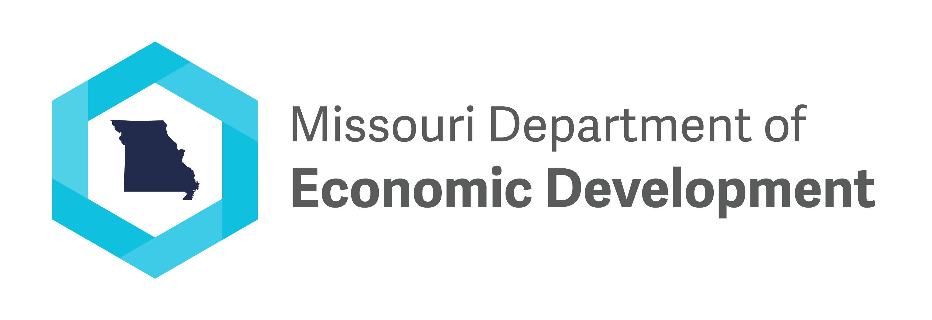

United Way Agency Contact Information

March 4, 2022

Heart of Missouri United Way
Contact Name: Andrew Grabau
Contact Phone: (573) 443-4523
Contact Email: agrabau@uwheartmo.org
List of Counties Served: Boone, Cooper, Howard

United Way of Central Missouri
Contact Name: Ann Bax
Contact Phone: 573-636-4100
Contact Email: ann.bax@unitedwaycemo.org
List of Counties Served: Cole, Moniteau, Miller, Osage, Camden, Southern Callaway, Morgan, Phelps, Maries

United Way of Greater Kansas City
Contact Name: Hannah Boehm
Contact Phone: 816.559.4769
Contact Email: Hannah.Boehm@uwgkc.org
List of Counties Served: Jackson, Clay, and Cass counties

United Way of Greater St. Joseph
Contact Name: Kylee Strough
Contact Phone: 816-364-2381
Contact Email: kylee.strough@stjosephunitedway.org
List of Counties Served:
Primary Missouri Counties: Buchanan, Andrew; Other Missouri Counties assigned to us, but our presence is less visible- Atchison, Caldwell*, Daviess*, Gentry*, Holt*, Worth*, Clinton, Dekalb, Harrison* and Livingston*
[Note: *The counties marked with an asterisk are ones where United Way of Greater St. Joseph is the assigned United Way for a portion of the County and another local United Way is assigned the other portion. Any manufacturers in any of the above counties are welcome to reach out to us and we will find their closest United Way and work jointly to ensure a good experience.]

United Way of Greater St. Louis
Contact Name: Mike Macauley
Contact Phone: 636-939-3300
Contact Email: michael.macauley@stl.unitedway.org
List of Counties Served: St. Louis City, St. Louis County, Jefferson, Franklin, St. Charles, Lincoln, Warren

United Way of the Mark Twain Area
Contact Name: Denise Damron
Contact Phone: 573-221-2761 (office), 573-795-6437 (cell)
Contact Email: director@unitedwaymta.org
List of Counties Served: Lewis, Marion, Monroe, Ralls, Shelby

United Way of the Ozarks
Contact Name: Stacey Funderburk
Contact Phone: (417) 863-7700
Contact Email: sfunderburk@uwozarks.org
List of Counties Served: Barry, Christian, Dallas, Douglas, Greene, Hickory, Laclede, Lawrence, Polk, Stone, Taney, Texas, Webster, Wright

United Way of Southeast Missouri
Contact Name: Mark Stone
Contact Phone: 573-334-9634
Contact Email: mark.stone@unitedwayofsemo.org
List of Counties Served: Cape Girardeau, Perry, Bollinger, northern Scott

United Way of Southwest Missouri and Southeast Kansas
Contact Name: Duane A. Dreiling
Contact Phone: 417-624-0153
Contact Email: ddreiling@unitedwaymokan.org
List of Counties Served: Jasper and Newton Counties.

