File Number: ____ _ ______

1. Employee Informaiton
Date/Time of Incident:_  Date/Time of Notification:_  Time Shift Began?_ | CASE NUMBER: _  Location: _
I am reporting a work related: ☐ Injury ☐ Illness ☐ Near miss
Is your Supervisor aware of the injury/near miss? Y ☐ N ☐
Your Name: | _
Job Title: | _
Supervisor: | _
Witness: | _
Witness: | _
Other: | _
Other: | _
Where exactly did it happen? _
2. Basic Information:

What were you doing at the time?
_

Describe step by step what led up to the injury/nearmiss?
_

What parts of your body were injured? If a near miss, how could you have been hurt?
_

What could have been done to prevent this injury/near miss?
_

3. Medical Informaiton
Has this part of your body been injured before? Y ☐ N ☐
If yes When? _ | What Happened previously? _

Did you see a doctor about this injury/illness? Y ☐ N ☐
If yes Who? _ | Doctors phone number: Text
Date/Time: _ | Supervisor: _

Using the pain man diagram on page two describe your injuries in detail.
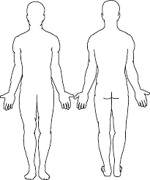_

4. Detailed Information
Description of Incident – (Provide a Detailed description) What are all possible causes or events that caused the incident.
_

5. Corrective Actions
Corrective Actions – (Provide a corrective action to prevent this in the future) Who is responsible for corrective action to prevent future incident.
_

5. Signatures
Your Signature: | Date/Time: _
Supervisor Signature: | Date/Time _

Human Resources Manager to Keep all Completed Forms on File.

