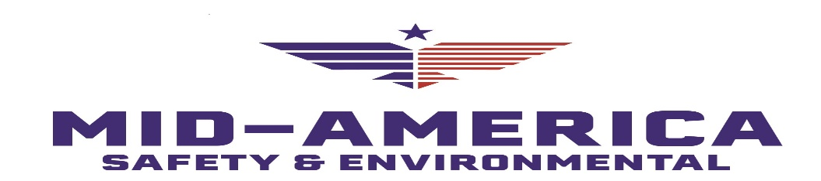
The time is right to review your records and conduct a safety compliance analysis. As of December, OSHA’s Site-Specific Targeting (SST) inspection program for non-construction employers with 20+ employees are back and will run for two years. Also, recently appointed Secretary of Labor Marty Walsh has directed the agency to ramp up inspections.
Most Likely to be Inspected
Under the updated and enhanced SST program, OSHA’s Office of Statistical Analysis will be crunching 2017-2019 reported injury and illness numbers and notifying area offices about organizations that:
- Have a high rate of employee Days Away, Restricted and/or Transferred (DART) time from work compared to their industry national average
- Have year-to-year upward-trending DART rates that put them above the industry average
- Are on the targeted list but have a low DART rate against their industry average (It’s a red flag for possible underreporting or improper encouragement of employees not to report injury/illness), or
- Are “non-responders” that do not turn in their Form 300A logs on time
Your DART can be calculated by adding the numbers in columns H and I of your Form 300 log, dividing that by the number of hours all employees worked, and multiplying it by 200,000 (100 employees working 40 hours a week for 50 weeks).
Getting Ready
To stay off OSHA’s radar:
- Keep your employee safety training up to date and document it
- Encourage employee involvement in the workplace safety program
- Ensure the protection of employee privacy protection (to avoid whistleblower discrimination scrutiny)
- Establish a system to retain and update your safety records
- Complete, certify, and submit your legally required injury and illness logs to OSHA promptly, and
- Complete OSHA and Bureau of Labor Statistics surveys
To prepare for a possible OSHA inspection, check the agency’s most frequently cited standards and review your company safety inspection records and any applicable abatement plans (failure to abate fines can carry a price tag as high as $13,653 per day beyond the deadline).
It is also a good idea to double-check if there are any local or national emphasis programs you need to pay attention to.
Knock at the Door
Because OSHA does not have to give advance notice of an inspection unless there are unusual circumstances, it is strongly recommended to have clear procedures for what to do if an inspector shows up.
Select a safety manager-led team for facilitating compliance inspections that includes HR (oversight of training records), maintenance (to address engineering controls), safety committee members, union representatives with experience in safety and health, etc.
Need help in preparing for an OSHA inspection? Mid-America Safety & Environmental is available for compliance inspections, including mock OSHA inspections as well as plan and program review. Contact us at safety@midamsafety.com or 833-674-2457.

